Documentation of SME

1. **SME Sign-Up:**

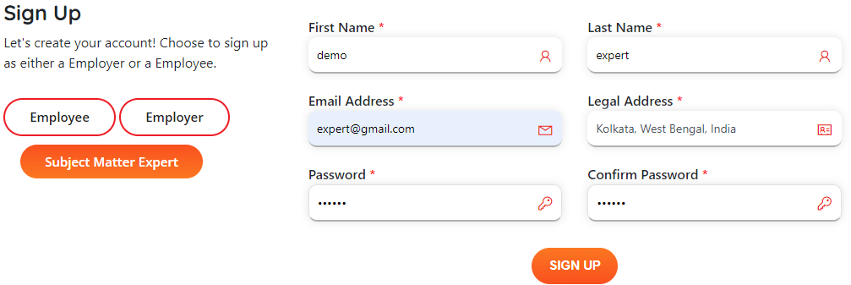

1. **Email Notification:**

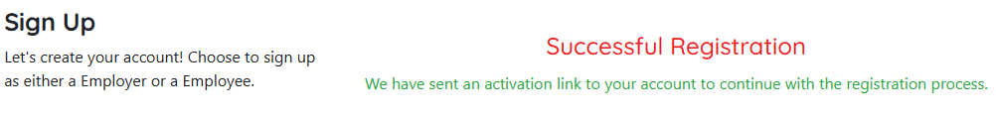

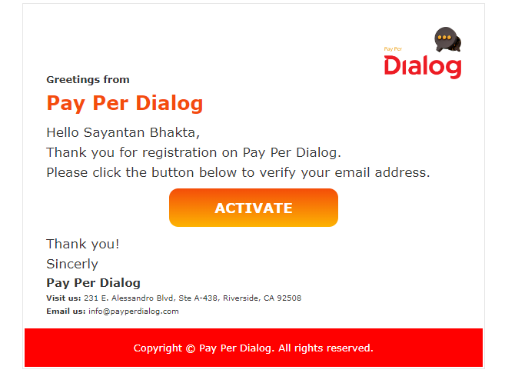

User can only login after clicking on the **“Activate”** button.

1. **Login as an SME:**

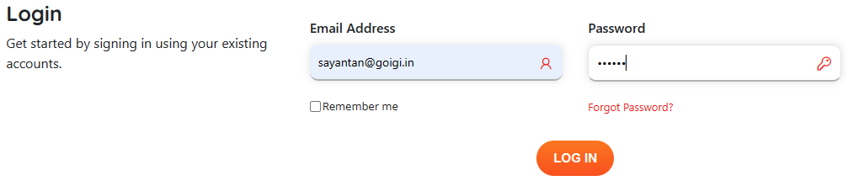

1. **Profile Page after login:**

After login using the valid credential, user will redirect to their profile page, it will show a pop-up to accept the user agreement. After accept it will reload the profile page.

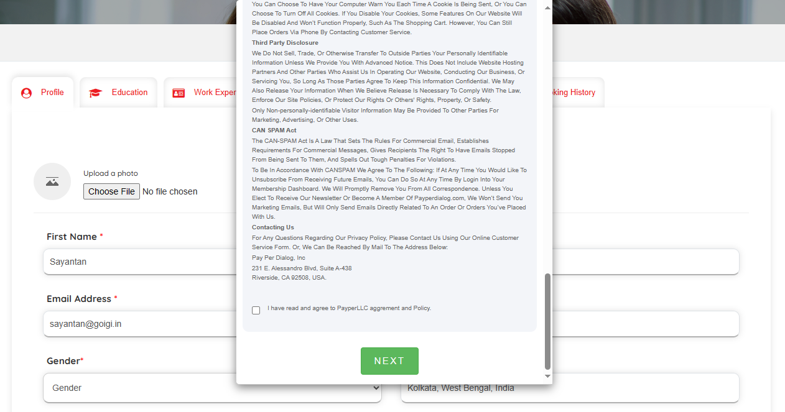

1. SME need to fill the required fields before accessing the other tab. SME can add “Education”, “Work experience”, “My Jobs”, “Message”, “Availability”, and “Booking History”.

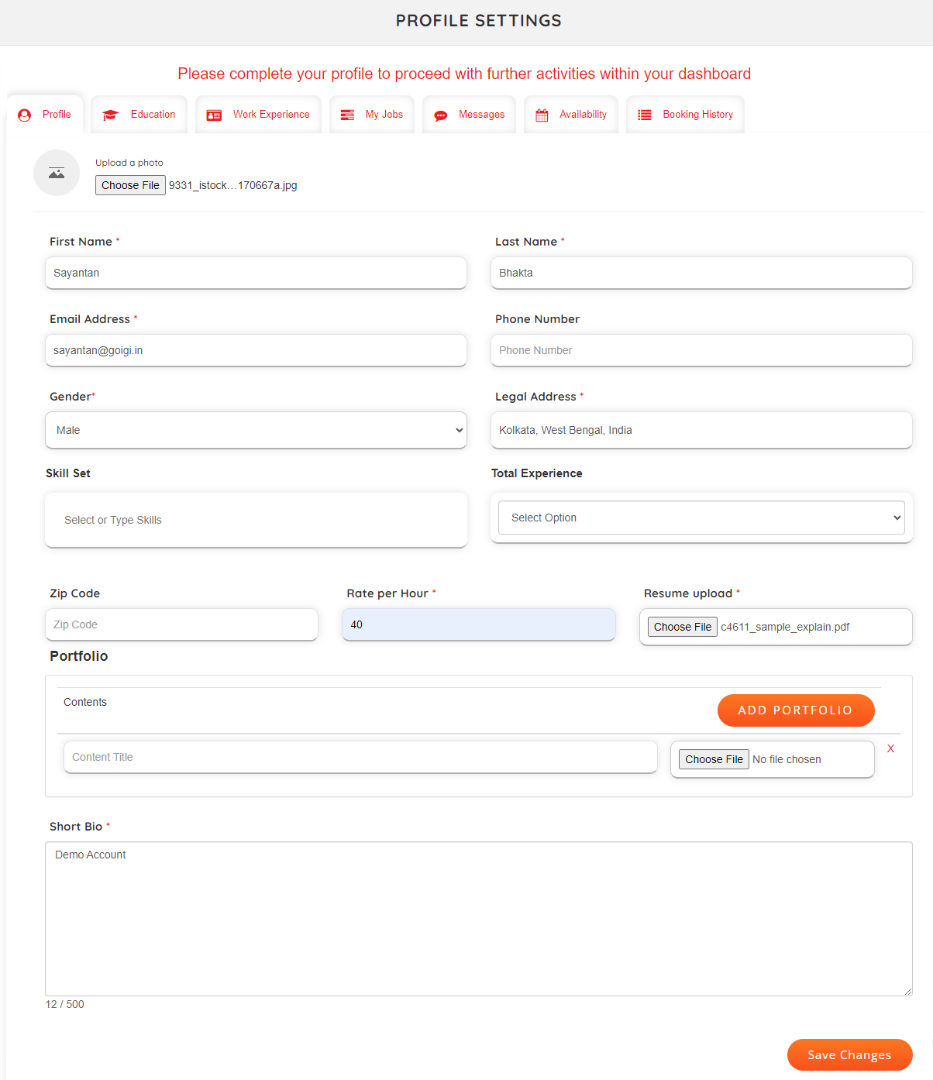

1. **SME Education:**

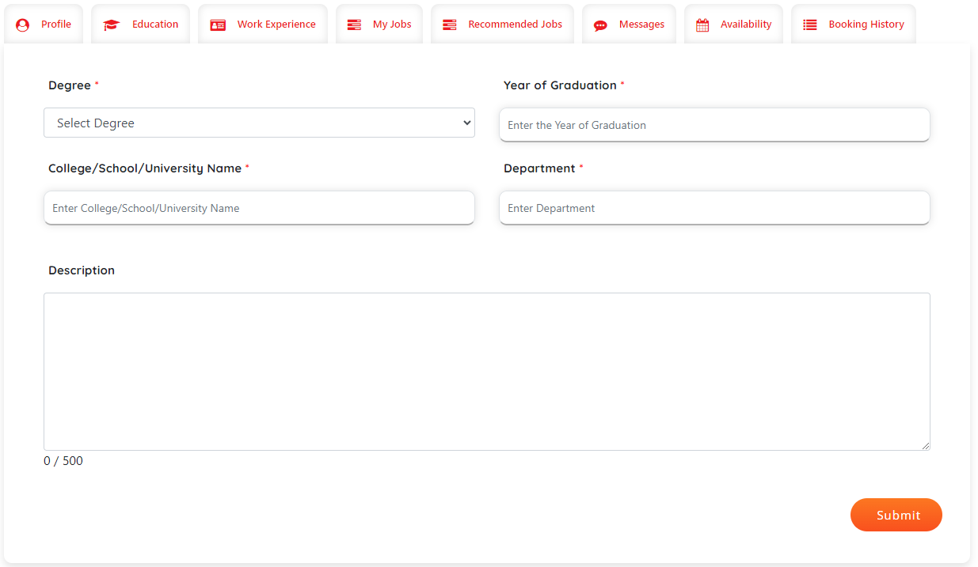

**Education Details will show in SME details page.**

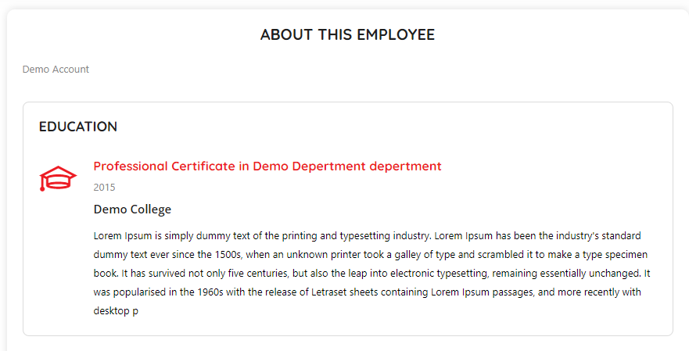

1. **Work Experience:**

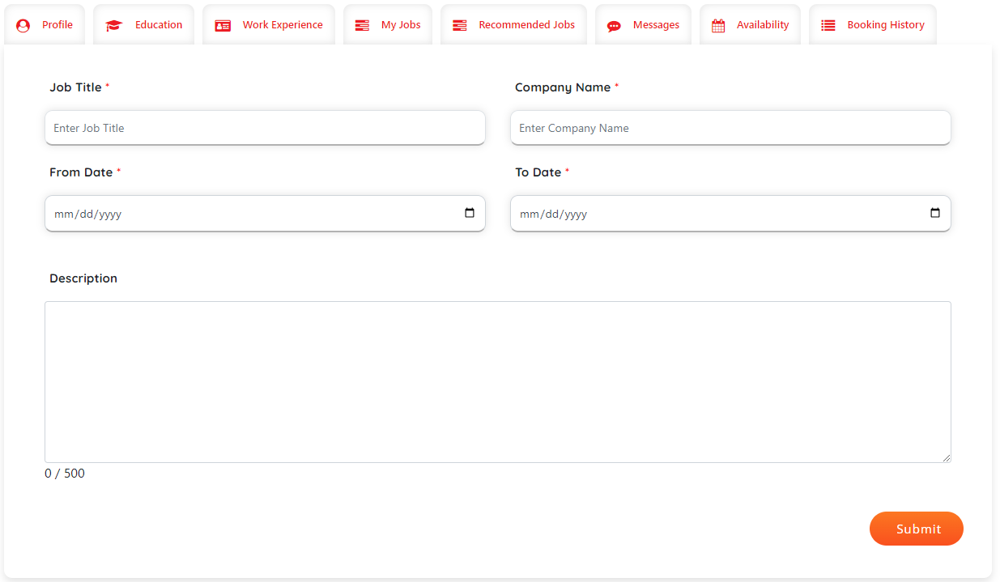

**Work Experience details will show in SME details page.**

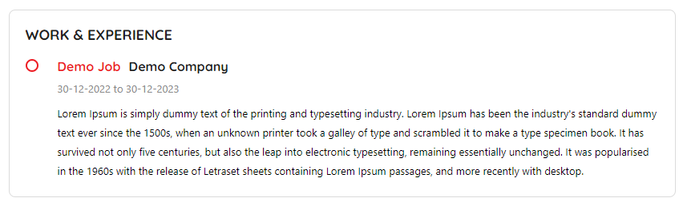

1. **My Jobs for SME:**

In my jobs “Apply for jobs” button will be there, if there is no job bid by SME.

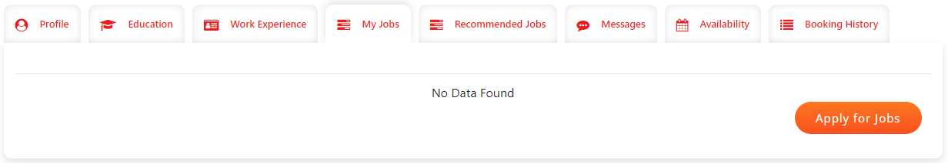

Click on the “Apply for jobs”, employee will be redirecting to the Job listing page.

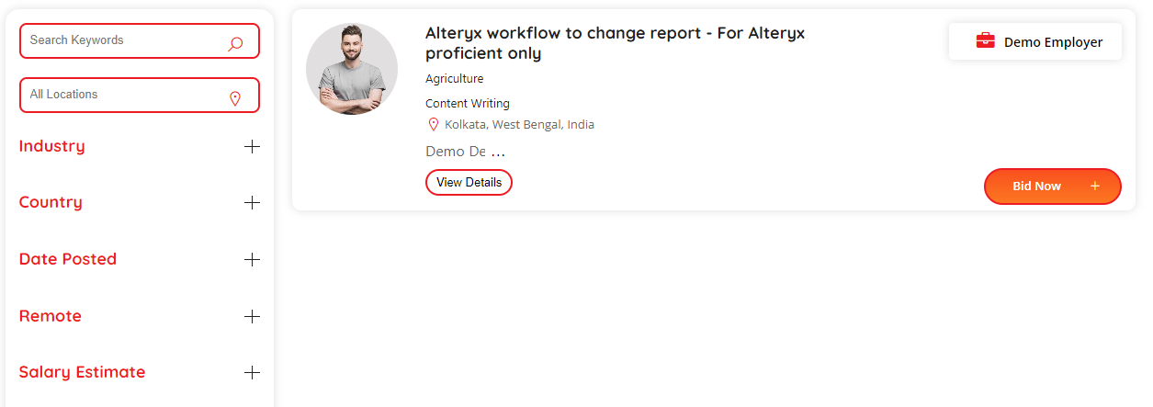

1. **Bid Now:**

Click on “Bid Now” will redirect user to Job details page, where SME can bid job based on their preference.

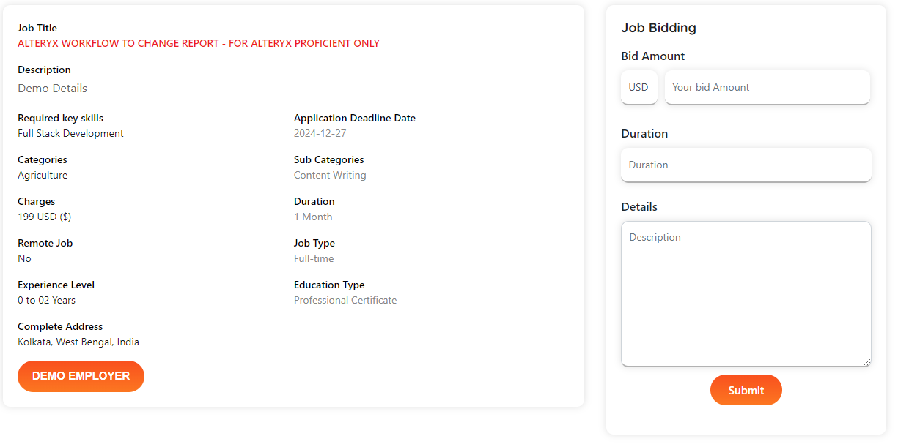

Without updating the profile data SME cannot be able to bid job. Job bid option will be disabled for those.

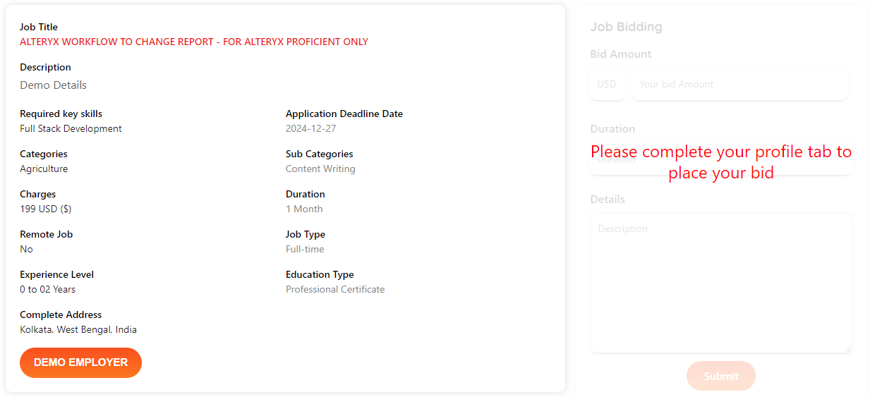

1. After job bid the listing will show in the My job profile. By default, it will show as pending.

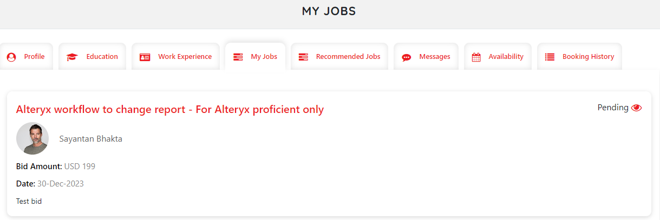

Once the status became “Selected” that particular employer and SME can communicate through “Message” tab.

1. **Availability:**

Once user click on the calendar date, one pop-up will appear, where SME can set availability for each date.

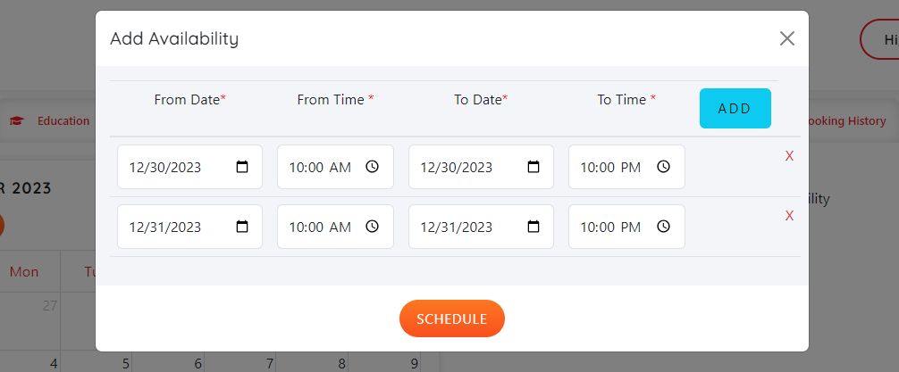

After adding the data, the listing page will be

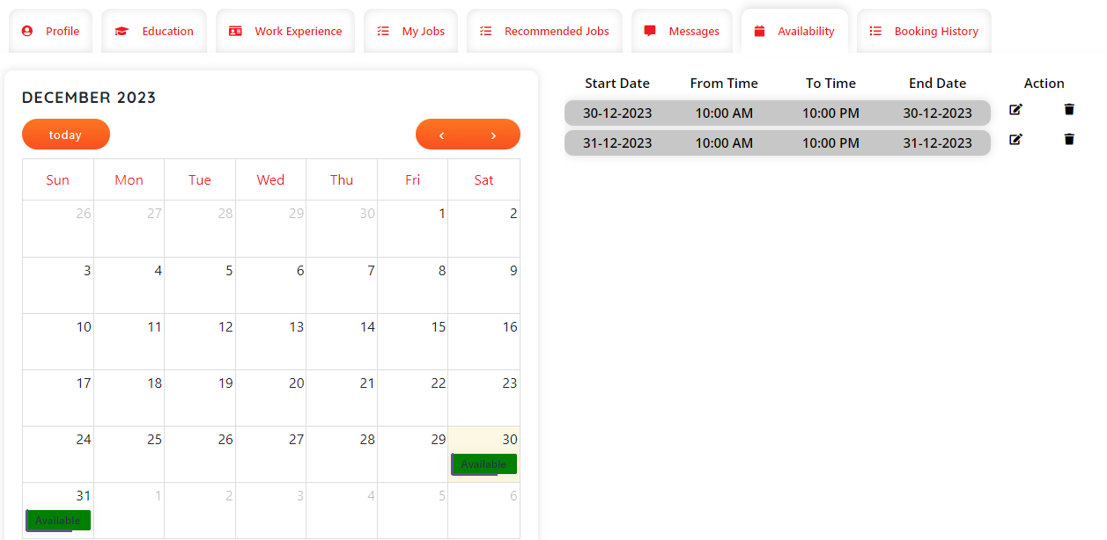

User can edit/update, and delete the availability. If any employer books any slot for a particular date, SME will not update or delete that availability data.

1. **Booking Details:**

Once any employer books any slot from SME details page, the booking data will show in this tab.

